Data Fundamentals

29/01/2025

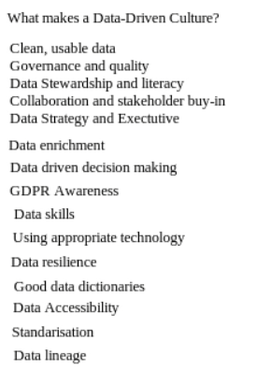

- Data-Driven Culture
  - The session focused on building a data-driven culture within organizations.
  - Key elements of a data-driven culture include:
    - Clean, usable data
    - Data governance and quality
    - Data stewardship and responsibility
    - Data literacy across the organization
    - Collaboration and stakeholder buy-in
    - Executive support and data strategy
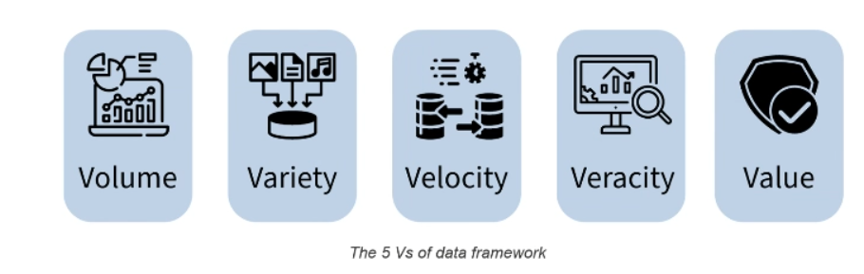
- Data Engineering Role
  - Data engineers play a crucial role in enabling businesses to harness the power of big data.
  - They design, build, and maintain infrastructure and systems for data collection, storage, and processing.
  - Data engineers ensure data quality and reliability, which is essential for data-driven decision-making.
- Big Data vs. Small Data
  - Big Data: Characterized by high volume, variety, velocity, veracity, and value. Examples include social media platforms analyzing billions of user interactions daily.
  - Small Data: Smaller in volume, often structured, and easier to analyze. Examples include personal fitness trackers recording daily steps and calories.
- Data Formats and Standards
  - Common data formats include JSON, CSV, and XML.
  - Cloud computing standards like AWS Well-Architected Framework and OpenAPI Specification were discussed.
  - Regulatory requirements such as GDPR (General Data Protection Regulation) and ISO 27001 (Information Security Management) were highlighted.

Best Practices in Data Engineering
- Scalability and Reliability
  - Data systems must handle growing data volumes without sacrificing performance.
  - Redundancy and disaster recovery plans are essential for safeguarding data.
- Data Documentation
  - Proper documentation ensures that data is understandable and usable by others.
- Data Ethics
  - Ethical guidelines must be followed to ensure responsible data usage.

Activity: Employee Churn Decision Tree
- Objective: Build a decision tree for predicting employee churn.
- Key Factors Identified:
  - Salary
  - Job satisfaction
  - Work hours
  - Career development
  - Manager and colleague relationships
  - Flexibility and work environment
- Outcome: The activity helped participants understand how to identify key decision points and factors that influence employee retention.

Key Takeaways:
- Engagement is Key: Active participation through polls, reactions, and discussions enhances the learning experience.
- E-Learning is Essential: Completing e-learning modules before sessions helps in better understanding and engagement.
- Data-Driven Culture: Building a data-driven culture requires clean data, governance, literacy, and stakeholder buy-in.
- Data Engineering Role: Data engineers are crucial in designing and maintaining systems that enable data-driven decision-making.
- Big Data vs. Small Data: Understanding the characteristics of big data (volume, variety, velocity, veracity, value) is essential for data engineers.
- Best Practices: Scalability, reliability, documentation, and ethics are key best practices in data engineering.
- Learning Journal: Reflecting on learning through a journal hosted on GitHub is a valuable practice for continuous improvement.

